Lab No. 10

Operator Overloading

(Polymorphism)

Lab Objectives | Following are the lab objectives:  - Static (compile-time) polymorphism  - Operator Overloading
Student ID | 10011 | Student Name |  | Sajjal Tariq
 | Marks |  | Obtained Marks |  | Comments
Task 1 | 15
Task 2 | 15
Task 3 | 15
Total Marks | 45
 | Lab Instructor

Lab Objectives and CLOs Mapping

Lab Objectives | CLOs
Lab Objectives | a | b | C
1
2

Instructions
- This is individual Lab work/task.
- Complete this lab work within lab timing.
- Discussion with peers is not allowed.
- You can consult any book, notes & Internet.
- Copy paste from Internet will give you negative marks.
- Lab work is divided into small tasks, complete all tasks sequentially.
- Show solution of each lab task to your Lab Instructor.
- In-Lab Exercises/Tasks
- Write your code at provided space after each question
- You need to upload code for all tasks at Google Class.

Lab Tasks
Task 1 (15 mark)
Create a class Point which can store x & y coordinates of a point exists in plane. Also define following members of class:
- Default constructor
- Parameterized constructor
- Operator +
- Operator -
- Operator *
- Operator /
- Operator !=
- Operator ==

CODE:
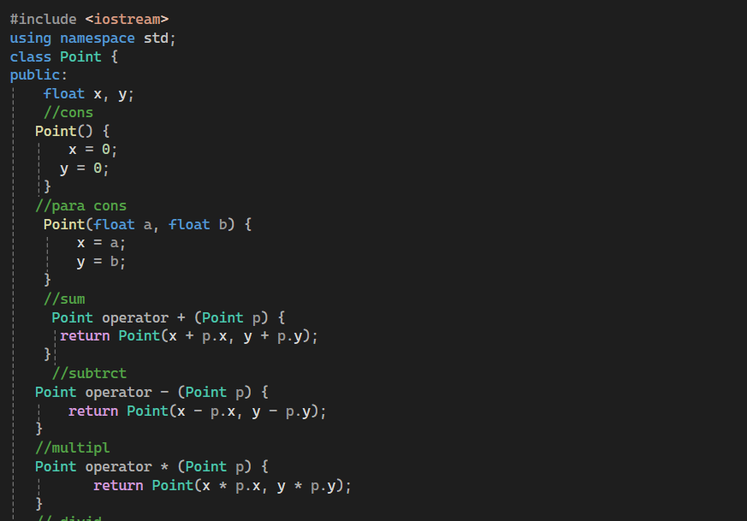
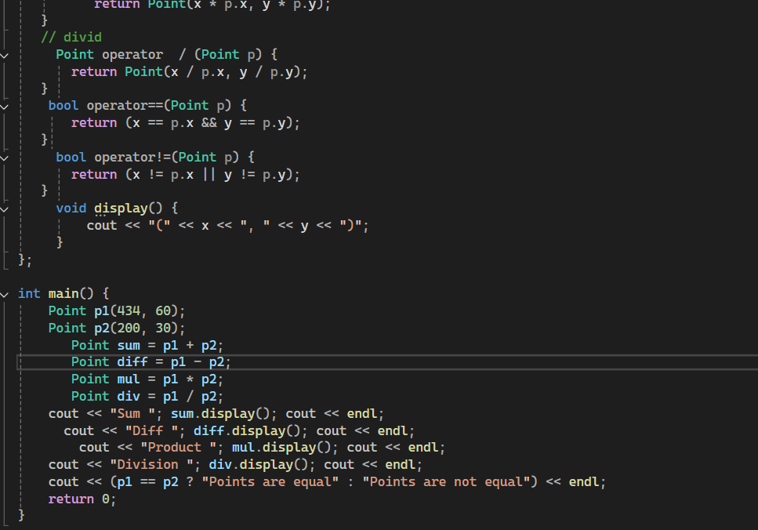
OUTPUT:
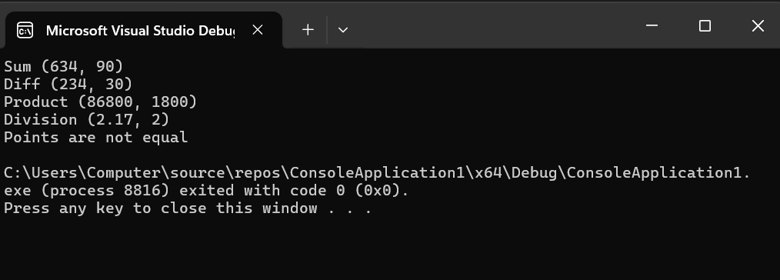

Task 2 (15 mark)
Create a class RationalNumber which can store any rational number, expressed in the P / Q form. Class also contains following members:
- Default constructor
- Parameterized constructor
- Operator +
- Operator -
- Operator *
- Operator /
- Operator !=
- Operator ==
- Operator <
- Operator >
- Operator <=
- Operator >=
(Past your code here.)
CODE:
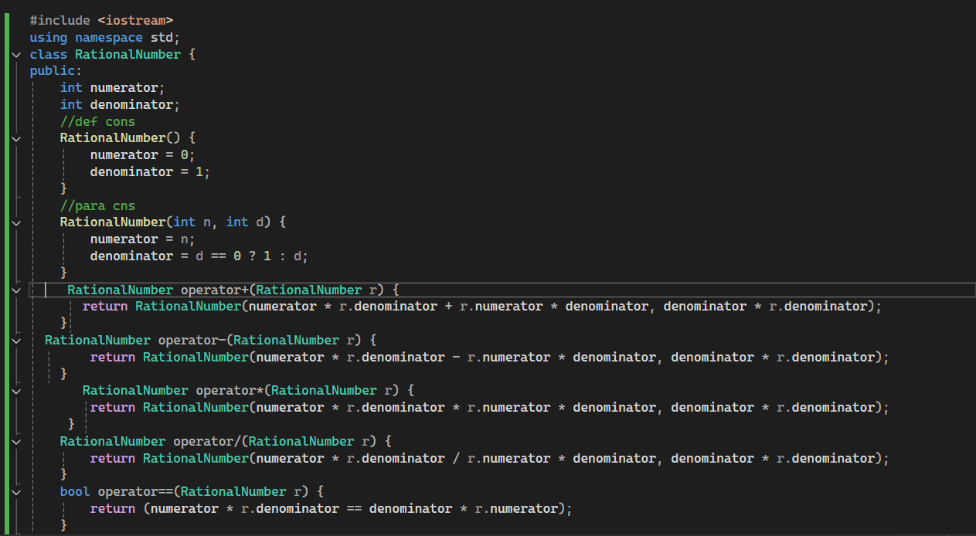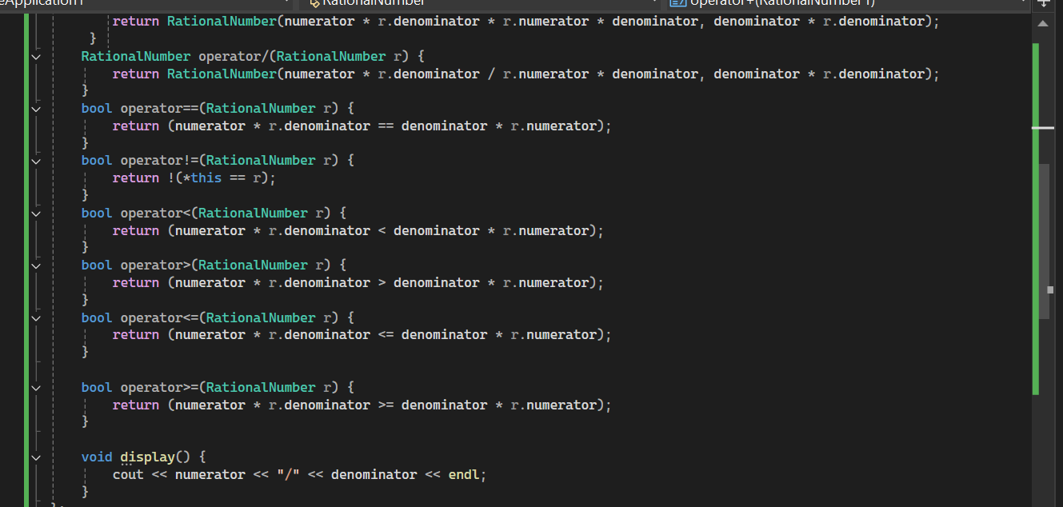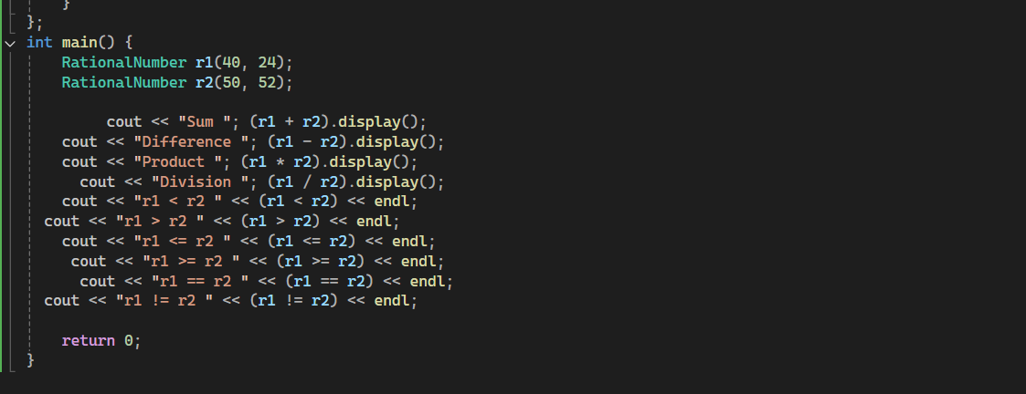
OUTPUT:
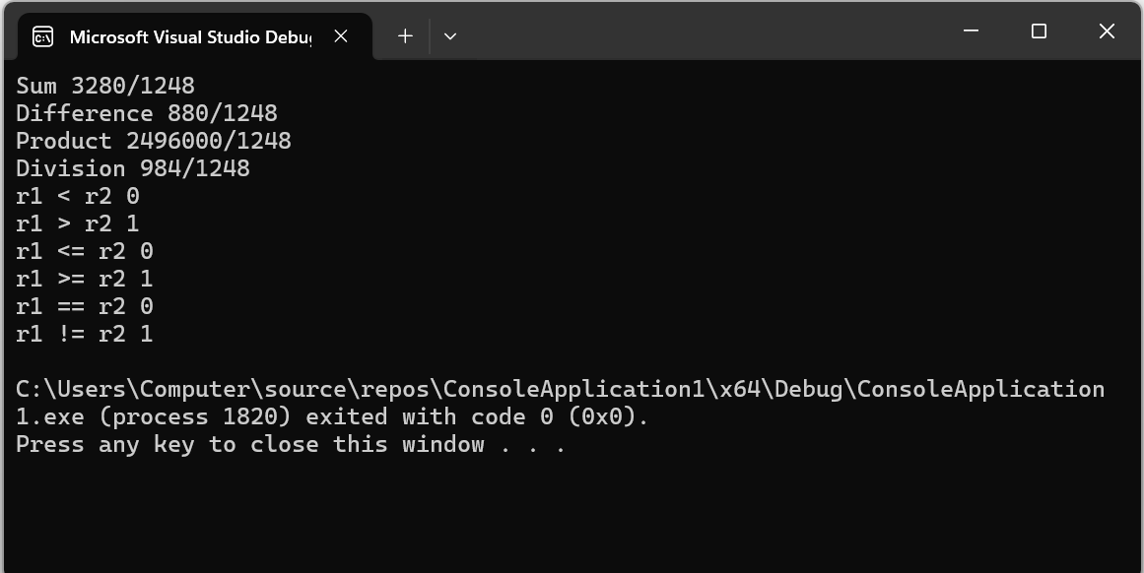
Task 3 (15 mark)
Create a class Distance which can store any distance in the form of feet and inches, e.g. 9’6’’ (9 feet and 6 inches). Class also contains following members:
- Default constructor
- Parameterized constructor
- Operator +
- Operator -
- Operator !=
- Operator ==
- Operator <
- Operator >
- Operator <=
- Operator >=

CODE:

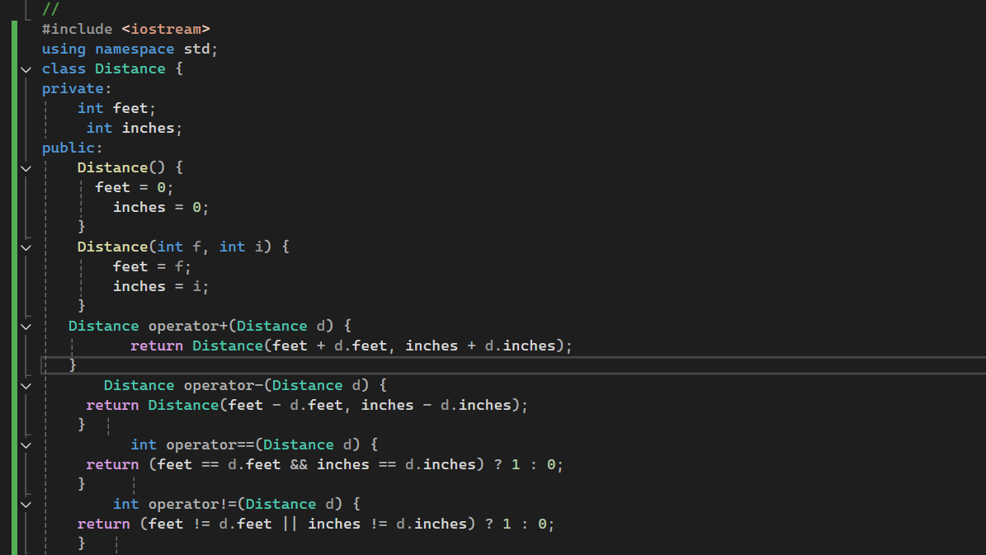
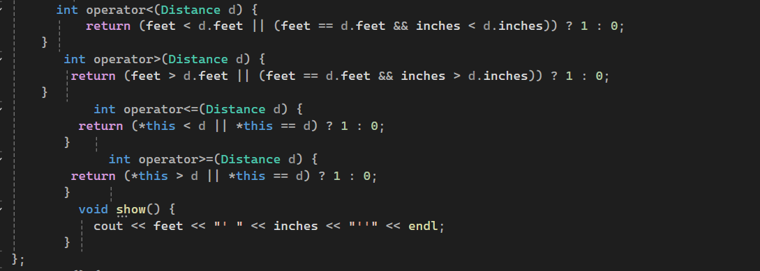

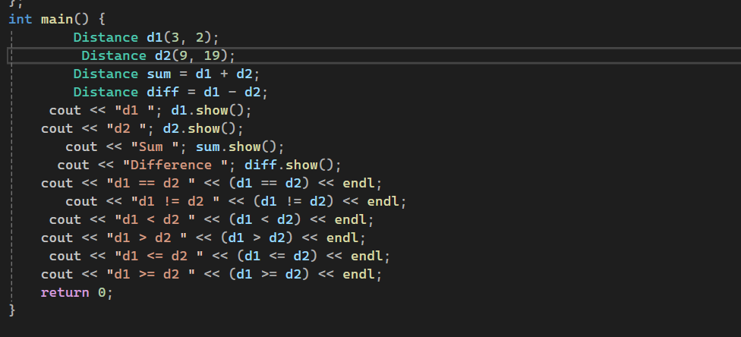

OUTPUT:
